Temple Inn & Suites

Maretta wight

CIT 230

# **Overview**

## Site Name

Temple Inn & Suites

## Domain Name

www.templeinnandsuites.com

## Site Purpose

The Temple Inn & Suites is a hotel chain headquartered in Bethesda, MD that builds and manages specialized hotel accommodations near temple locations of The Church of Jesus Christ of Latter-day Saints around the world. The owner-operated company caters to temple workers, patrons, and their families by providing specialized services and accommodations that meet the needs of those patrons. The hotel accommodations and services are available to anyone willing to abide by the terms and policies outlined by the company. The overall goal of the website project is to promote and provide information about the specialized services that this hotel chain offers to meet the needs of temple patrons who come to serve in the temple or who participate in events such as sealings, weddings, receptions, and youth trips. The website should reflect the Church culture and be designed to support a temple-oriented theme as well as the concept of being a haven of comfort and accessibility.

## Target Audiences / Personas

**Primary Audience:** Mature and/orretired singles or couples. Temple workers or temple patrons.

**Age:** 50-80

**Financial situation:** Low to moderate income levels. Looking for low cost accommodations that will enable them to attend the temple or reside near the temple while serving there.

**Interests:** They are wanting to serve in the temple, sometimes at great personal sacrifice.

**What they want:** A clean comfortable place to stay near the temple that will allow them to attend several sessions, or a place to live as they serve as temple missionaries.

**What their needs are that aren't being met**: The aren’t many temples with low cost accommodations nearby that understand the needs of temple visitors.

**How my audience will usually access my site:** Most will access the site through desktops and some laptops.

**Secondary Audience:** Young adults, engaged and coming to get married. Young to middle-aged adults married with young children.

**Age:** 20-50

**Financial situation:** Low to moderate income levels. Looking for low cost accommodations that will enable them to be married in the temple, or a low-cost place to stay that provides child care while they attend the temple.

**Interests:** They value time with family, and want to serve or get married in the temple.

**What they want:** A clean low-cost place to stay near the temple that will provide amenities they need and comforts they desire.

**What their needs are that aren't being met**: The aren’t many temples with low cost accommodations nearby that understand the needs of temple visitors.

**How my audience will usually access my site:** A good mix of mobile devices, laptops, and desktops.

# **Layout**

## Site Map

## Color Scheme

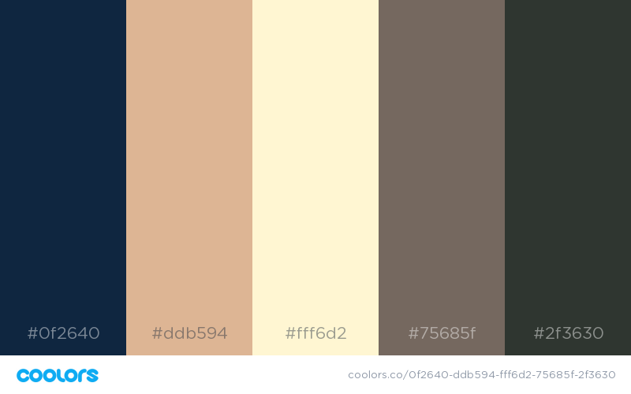

|  |  |  |  |  |
| --- | --- | --- | --- | --- |
| **Primary Color** | **Secondary** | **Accent (hover)** | **Accent (frames)** | **Text** |
| #0f2640  (Yankees Blue) | (Burlywood) | #FFF6D2  (Lemon Chiffon) | #75685f  (Deep Taupe) | #2F3630/ #ffffff  (Jet) / (white) |

## Typography

### Headline Font

Great Vibes

Body Text Font  
Roboto

## Wireframes

